Asia-China-Coin-Song-Coin Tallies

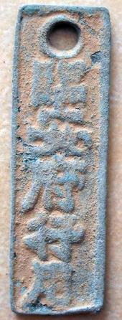 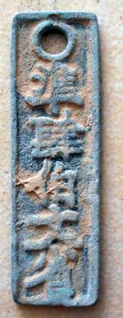

H 17.903 R 1, Height 6.2 cm.

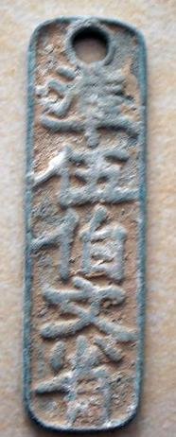 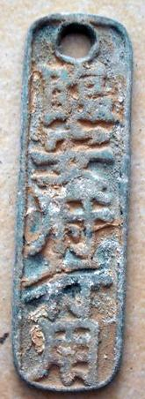

H 17.907 R0, Height 7.1 cm.